1. We need to install a plugin in Eclipse to support Gherkin Language (DSL).
   1. When you write your test cases in Gherkin Language, the eclipse plugin will highlight the syntax of Gherkin.
   2. The plugin supports all the Gherkin test cases. So, if there is any error, the plugin will report.
2. 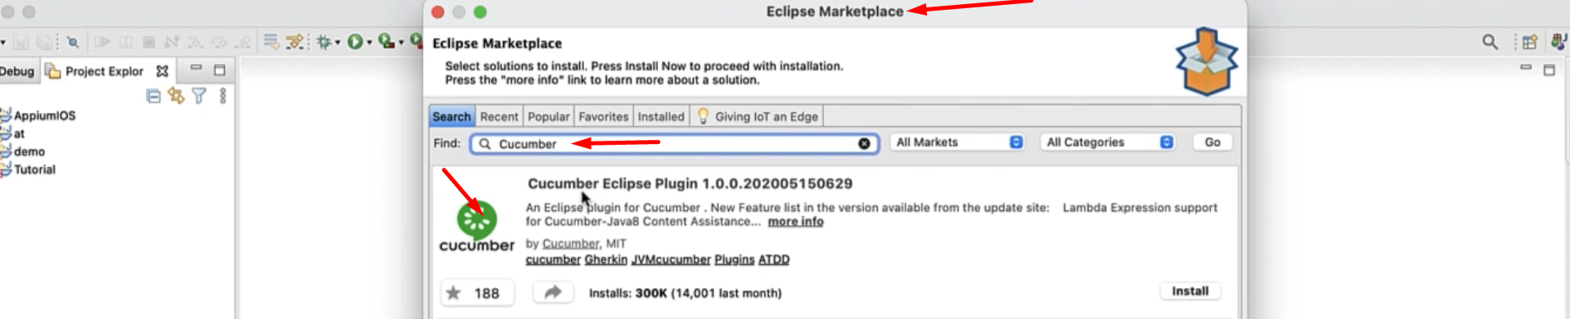  
   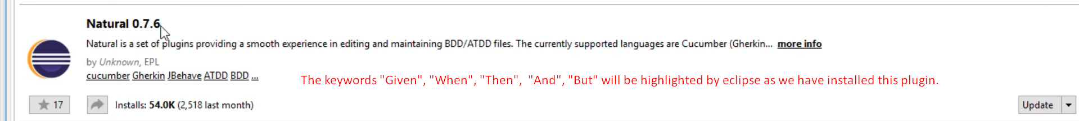
3. For Cucumber, there is standard skeleton (Project Structure for feature files), we have to follow. We can install Maven and maven can provide us such skeleton.
4. Let’s create a maven Cucumber Project.   
     
     
   Graphical user interface, text, application, email

   Description automatically generated  
     
   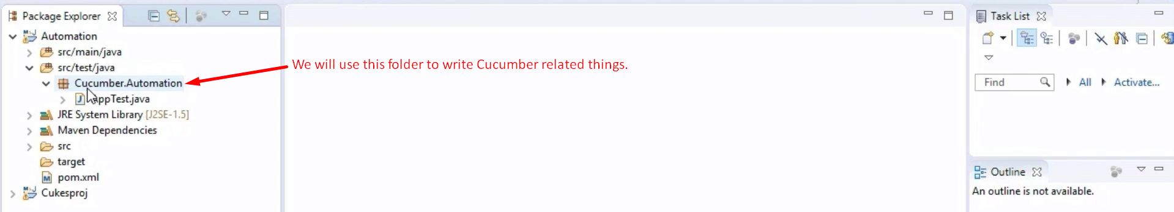
5. 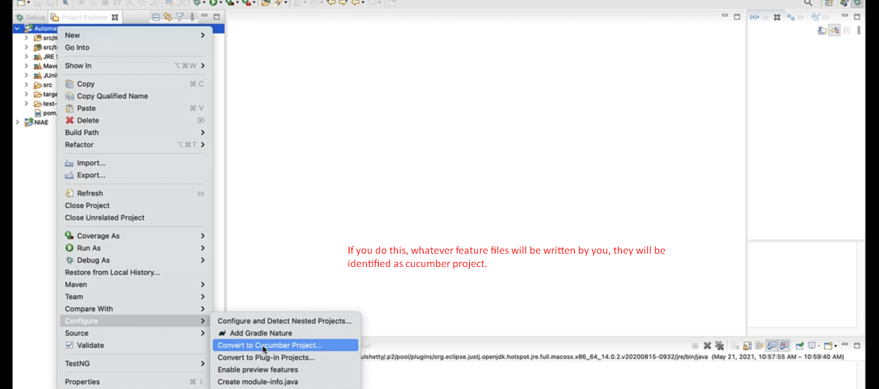  
   The above highlighted option will be visible after installing cucumber plugin that we already installed.